HỌ TÊN: NGUYỄN XUÂN TRỰC
MSSV: 1513804
======================o0o======================

LAB_2A_HTTP
1) Is your browser running HTTP version 1.0 or 1.1? What version of HTTP is the server running?
SOLUTION
Both of them are version 1.1
Source:
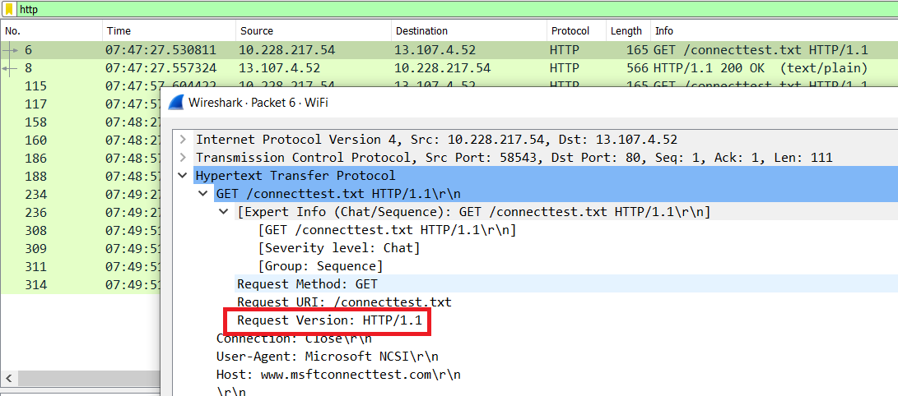

Destination:
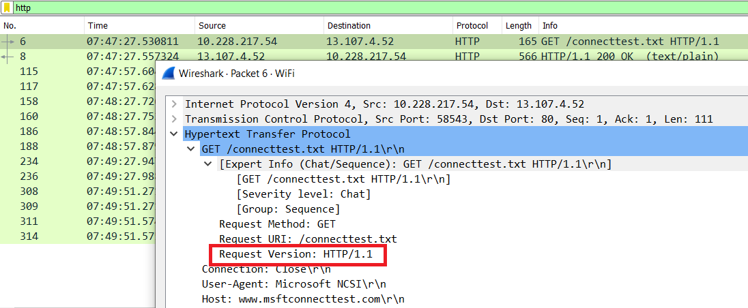
2) What languages (if any) does your browser indicate that it can accept to the server?
SOLUTION
en-US
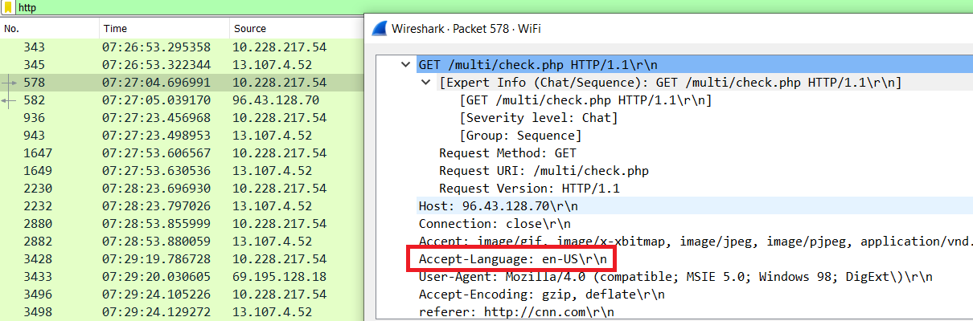

3) What is the IP address of your computer? Of the gaia.cs.umass.edu server?
SOLUTION
My computer : 10.228.217.54
gaia.cs.umass.edu : 128.119.245.12
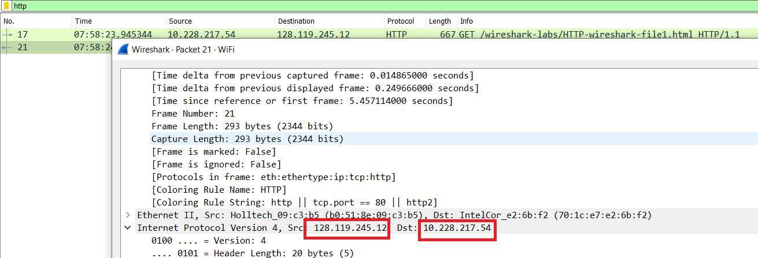

4) What is the status code returned from the server to your browser?
SOLUTION
Status code: 304
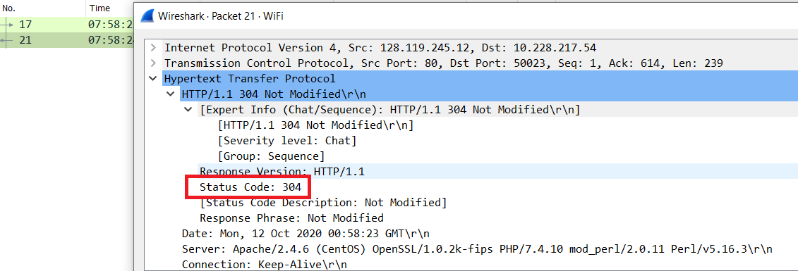

5) When was the HTML file that you are retrieving last modified at the server?
SOLUTION
Mon, 12 Oct 2020
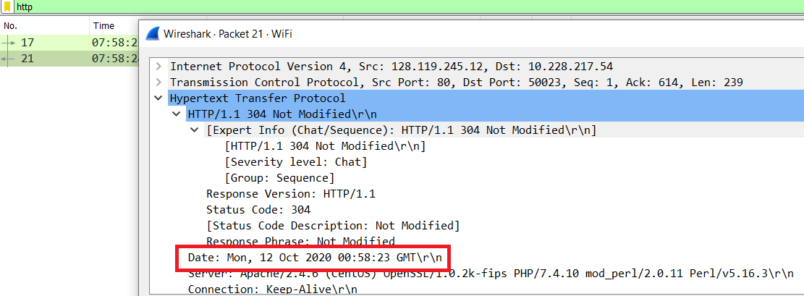

6) How many bytes of content are being returned to your browser?
SOLUTION
Length: 496459
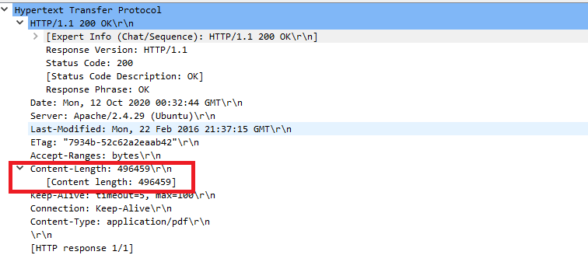
7) What is the server’s response (status code and phrase) in response to the initial HTTP GET message from your browser?
SOLUTION
We got a response that said ‘HTTP/1.1 304 Not Modified’.
Status code: 304
Respone Phrase: Not Modified
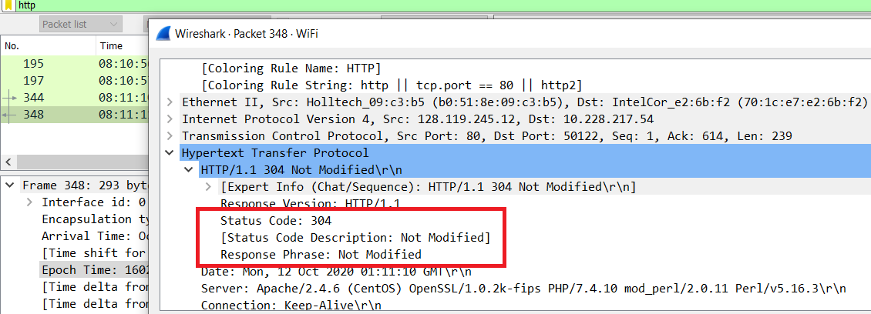

8) When your browser sends the HTTP GET message for the second time, what new field is included in the HTTP GET message?
SOLUTION
The screenshot of first HTTP GET message:
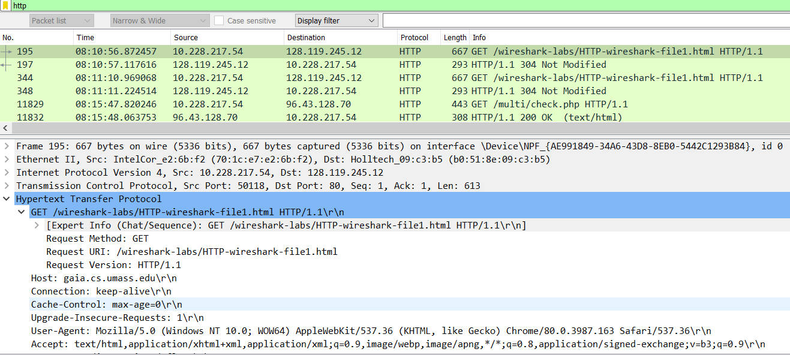

The screenshot of second HTTP GET message:
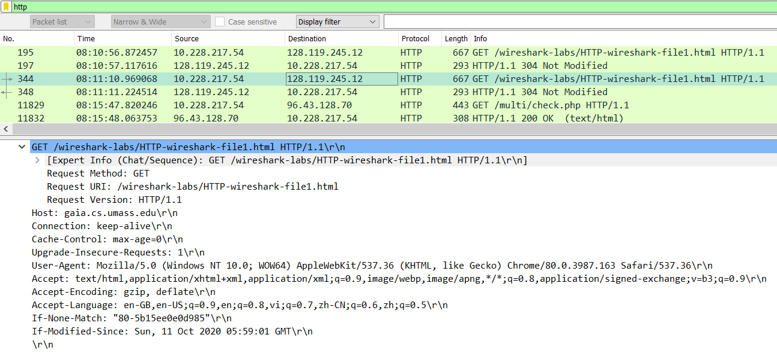

9) Inspect the contents of the server response. Did the server explicitly return the contents of the file? How can you tell?
SOLUTION
Not explicitly
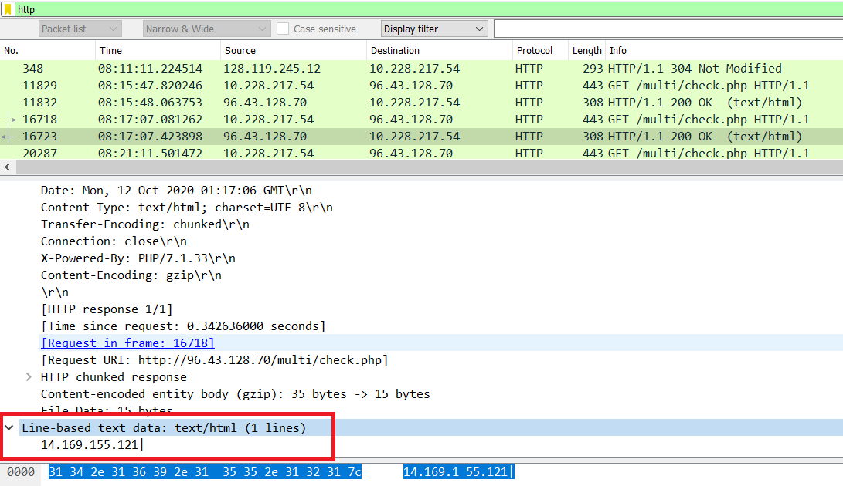

10) Now inspect the contents of the second HTTP GET request from your browser to the server. Do you see an “IF-MODIFIED-SINCE:” line in the HTTP GET? If so, what information follows the “IF-MODIFIED-SINCE:” header?
SOLUTION
Yes in the second HTTP message an IF-MODIFIED-SINCE line is included. The information that follows is the date and time that I last accessed the webpage.
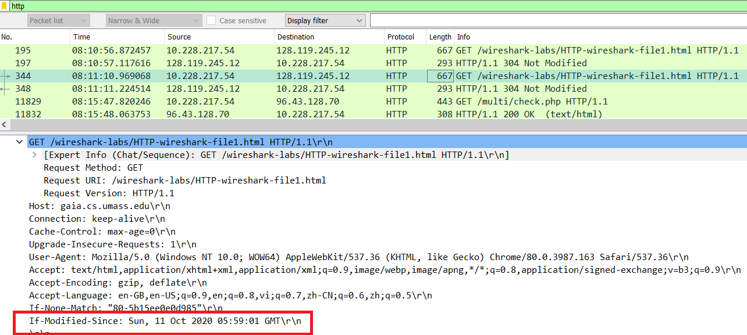

11) What is the HTTP status code and phrase returned from the server in response to this second HTTP GET? Did the server explicitly return the contents of the file? Explain.
SOLUTION
+ The HTTP status code is “304: Not Modified”
+ The server did not return the contents of the file because the browser simply retrieved the contents from its cache. Had the file been modified since it was last accessed, it would have returned the contents of the file, instead it simply told my browser to retrieve the old file from its cached memory.
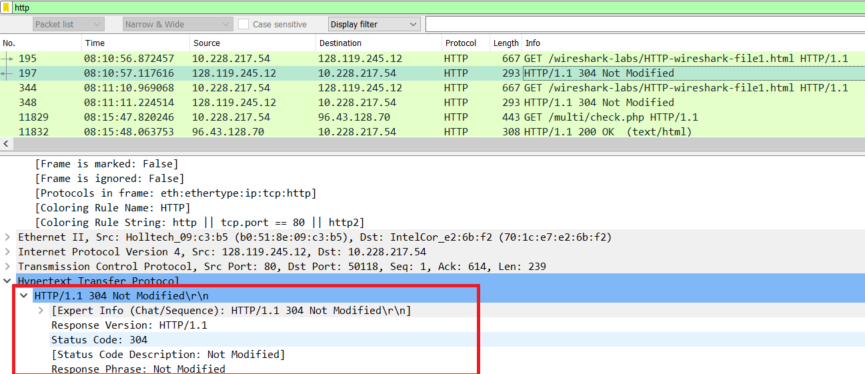
LAB_2B_DNS
1) Run nslookup to obtain the IP address of a Web server in Asia. What is the IP address of that server?
SOLUTION
I performed nslookup for www.vnexpress.net
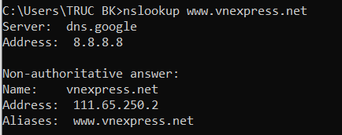

2) Run nslookup to determine the authoritative DNS servers for a university in Europe.
SOLUTION
I performed nslookup for a European University in Ioannina Greece
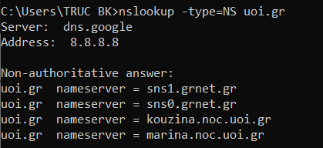

3) Run nslookup so that one of the DNS servers obtained in Question 2 is queried for the mail servers for Yahoo! mail. What is its IP address?
SOLUTION
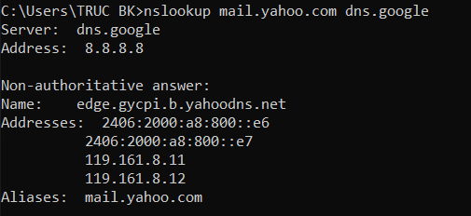
4) Locate the DNS query and response messages. Are then sent over UDP or TCP?
SOLUTION
Screenshot for DNS query:
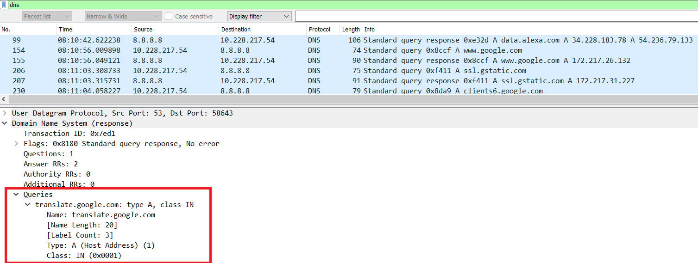

Screenshot for DNS response:
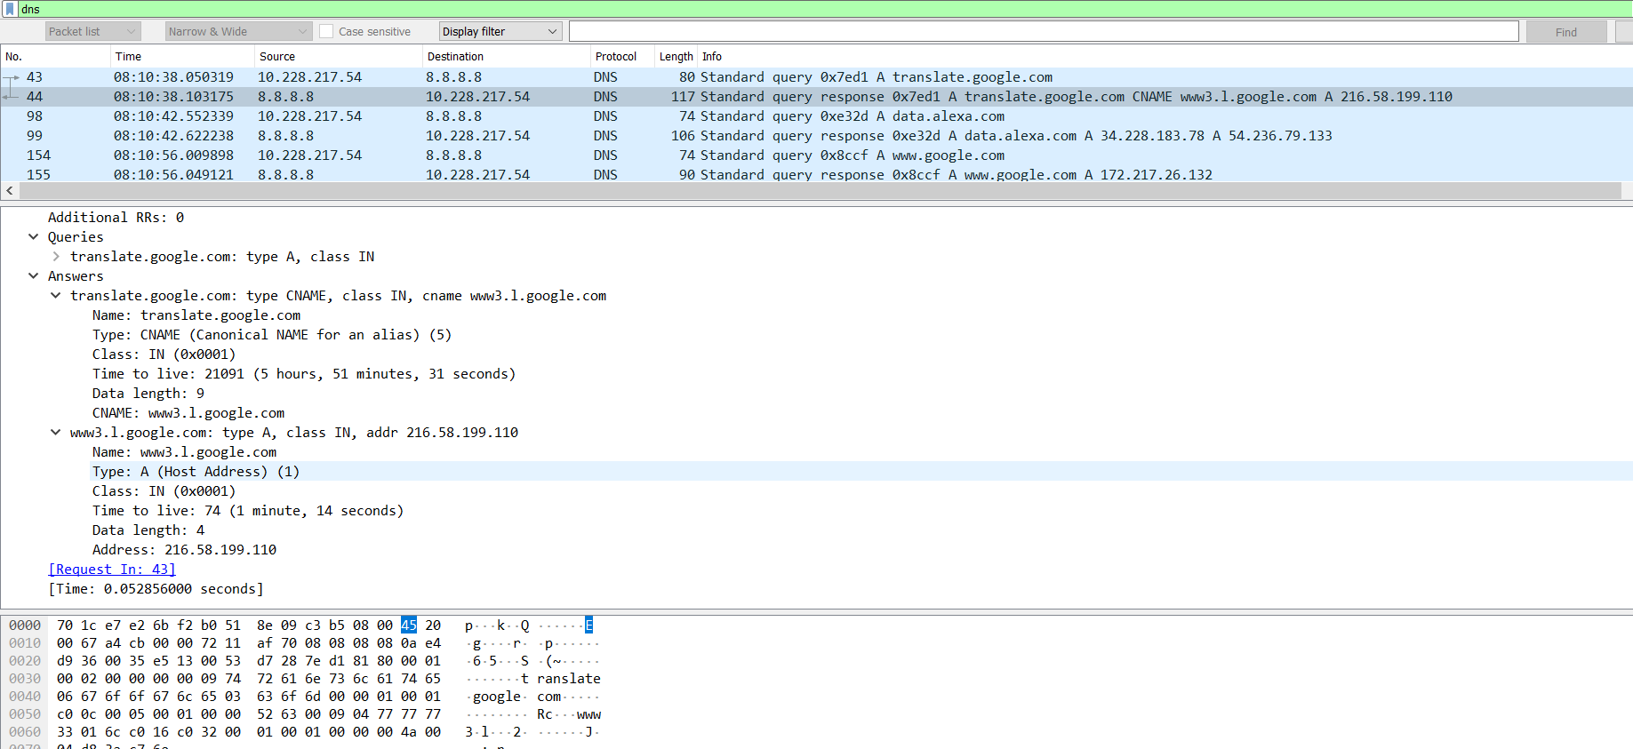
They are sent over UDP.

5) What is the destination port for the DNS query message? What is the source port of DNS response message?
SOLUTION

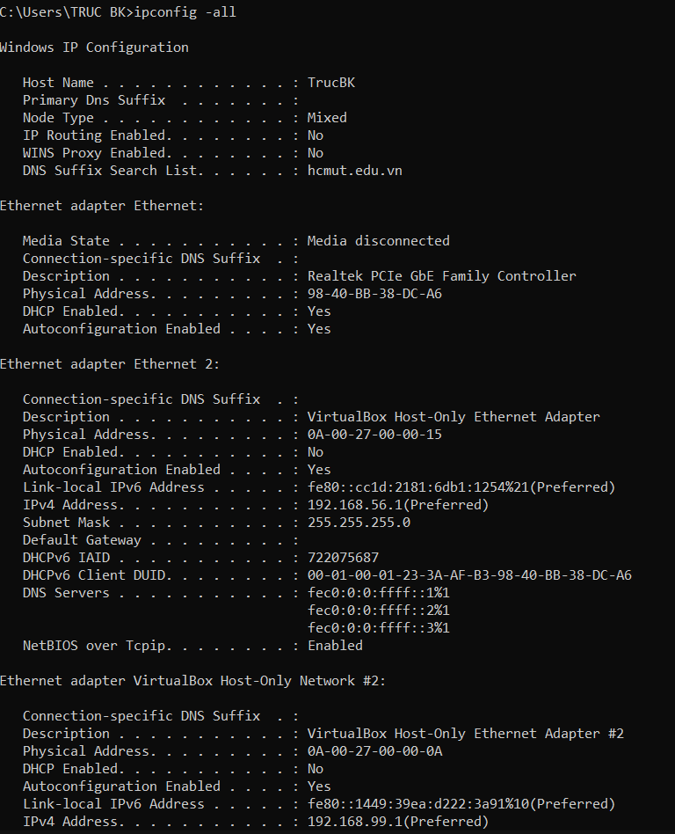

6) To what IP address is the DNS query message sent? Use ipconfig to determine the IP address of your local DNS server. Are these two IP addresses the same?
SOLUTION

